**Hayward RPP Weekly Update 6th June 2024**

I tried models that used only stags or only calves as density for first winter survival, but they were all insignificant.

I’ve tried again but for female calves and male calves survival, and I also used male calves or female calves as density, but the only model that was significant was hinds for female calves survival.

For first year spike length, should I use density in their birth year or the observed year? For now I’m using their birth year, and just as the first winter survival models, Hinds is the only density that’s significant.

When adding only stags or only calves for spike length, Stags density was significant but not Calves density. I thought competition between male calves might affect their spike growths too so I tried Male and Female Calves as density but they were insignificant as well.

The models seem to suggest when hind density is high, spike growth is faster, and spike growth is slower when stag density is high.

Here is an example of the models I’ve used:

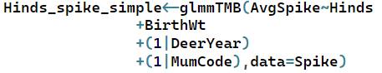

I wonder if I should also consider models with mum age and status or models excluding birth weight.

**Summary Yellow = insignificant (p>0.05)**

|  | **Coefficient** | **AIC** |
| --- | --- | --- |
| **Hinds** | **0.0136 (p=0.0026)** | **2681.7** |
| **Stags** | **-0.0101 (p=0.0020)** | **2681.6** |
| **Calves** | **0.0128 (p=0.19)** | **2688.4** |
| **Male Calves** | **0.0115 (p=0.56)** | **2689.7** |
| **Female Calves** | **0.0257(p=0.10)** | **2687.4** |
| **Adults** | **-0.0027 (p=0.47)** | **2689.5** |
| **Total** | **-0.0007(p=0.84)** | **2690.0** |
| **Livestock Units** | **-0.010 (p=0.29)** | **2688.9** |

**Hinds**

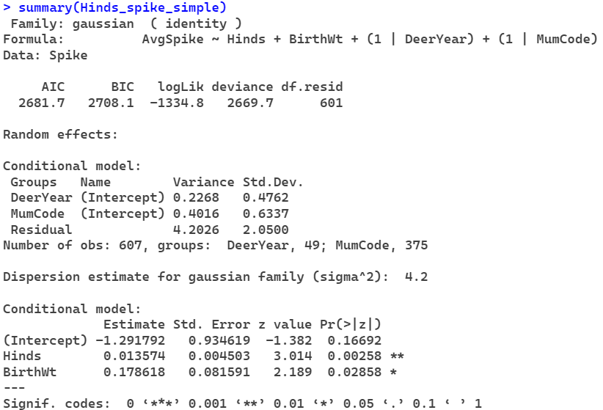

**Stags**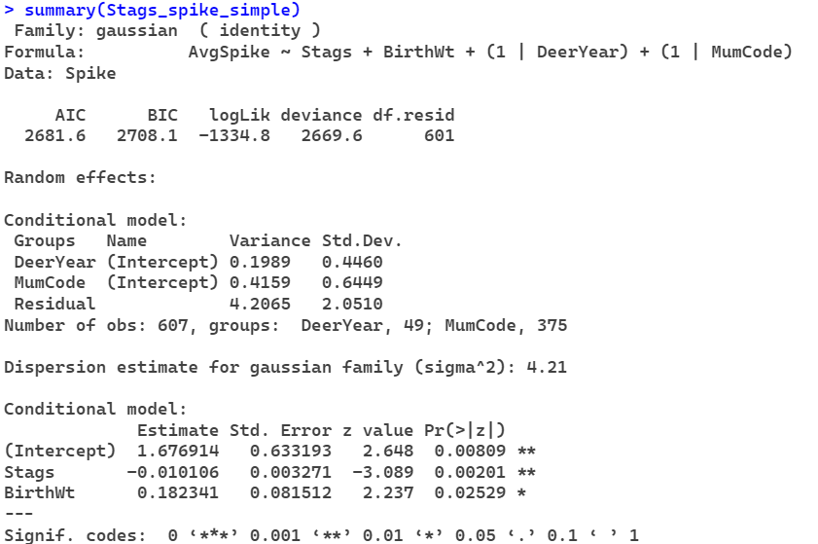

**Calves**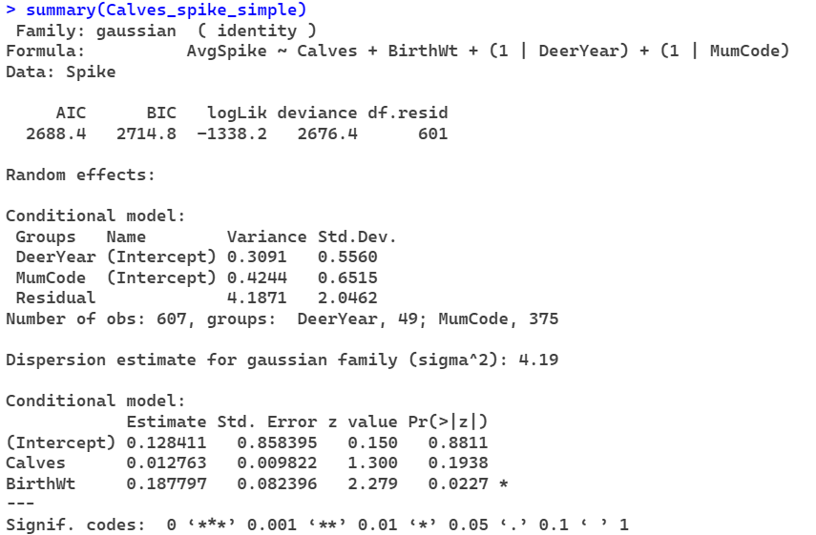

**Male Calves**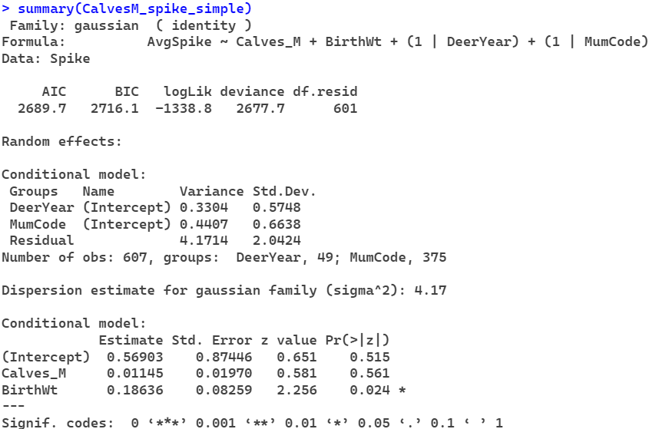

**Female Calves**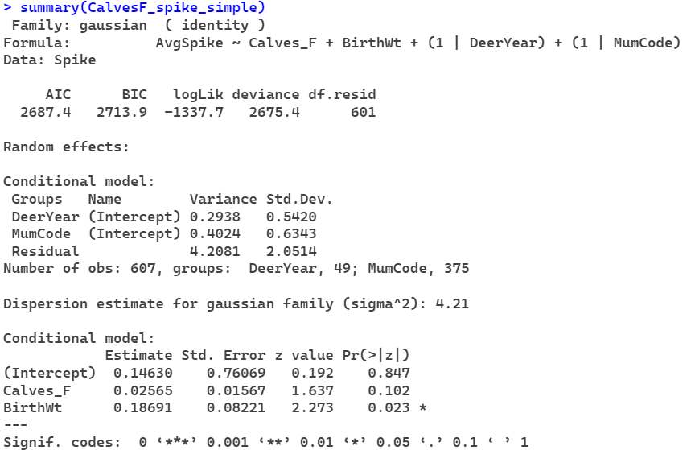

**Adults**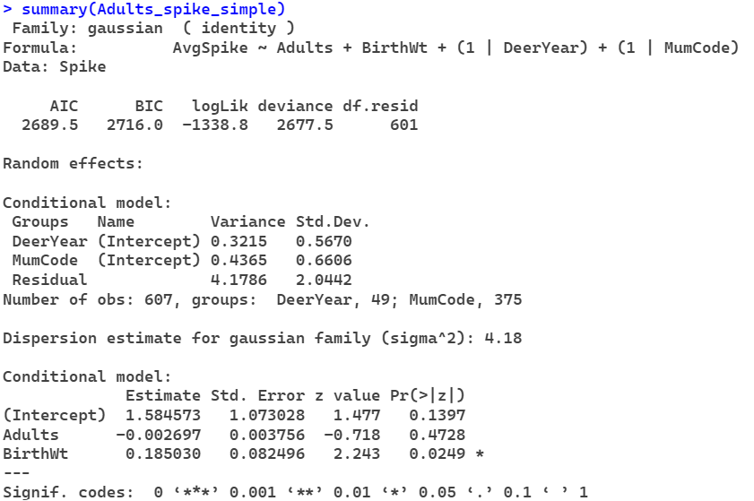

**Total**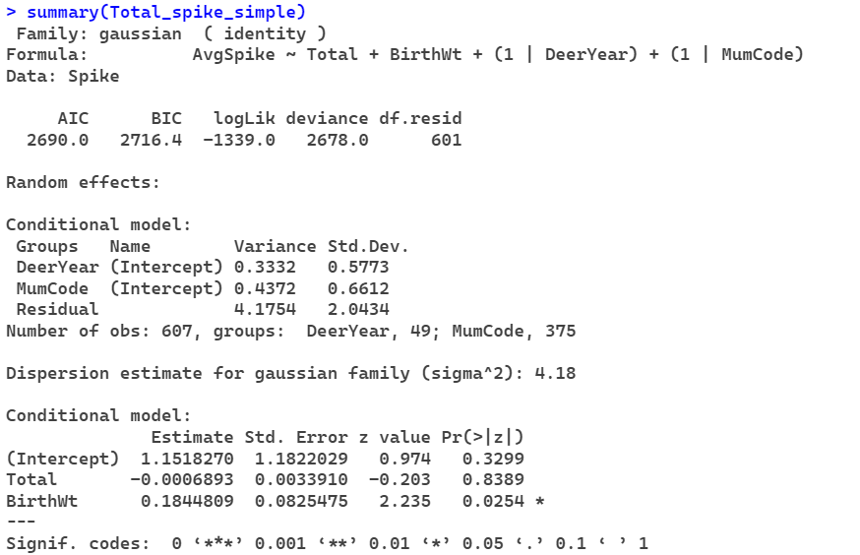

**Livestock Units**